Ideation Phase Brainstorm s Idea Prioritization Template

Date | 20 February 2026
Team ID | LTVIP2026TMIDS79334
Project Name | Empowering India: Analysing the Evolution of Union Budget  Allocations for Sustainable Growth
Maximum Marks | 4 Marks
Reference: https://www.mural.co/templates/brainstorm-and-idea-prioritization
Step-1: Team Gathering, Collaboration and Select the Problem Statement

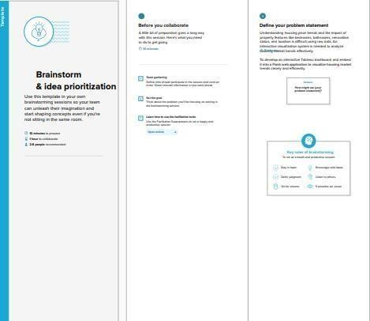
Step-2: Brainstorm, Idea Listing and Grouping

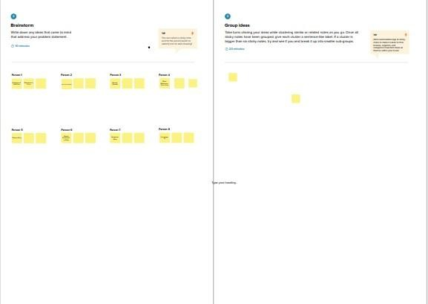
Step-3: Idea Prioritization

